Variation of upwelling signals detected within the four Eastern Boundry Upwelling Systems

Amieroh Abrahams ^{a,*}, Albertus J. Smit ª, Robert W. Schlegel ^{b}
ªDepartment of Biodiversity and Conservation Biology, University of the Western Cape, Private Bag X17, Bellville 7535, South Africa
^{b}Department of Oceanography, Dalhousie University, South St 6299, Halifax, Canada

Abstract

Keywords: Climate change, Upwelling, Seawater temperaturecoastal regions, , Code: R, coastal zone

1. Introduction

Occurring globally throughout the world's oceans, four major eastern boundary upwelling systems (EBUS) can be recognised; each significantly impacting associated coastal systems. These respective systems are characterized as vast regions of coastal ocean occurring along the western shores of continents bordering the Pacific and Atlantic Oceans (Bakun, 1990; Pauly and Christensen, 1995; Bakun et al., 2015, Bakun et al., 2010). The EBUS span a wide range of latitudes and are therefore spatially heterogeneous environments. The here referred to systems are the California, Humboldt, Canary and Benguela current systems. The California current is a broad, comparatively weak and shallow equatorward current spanning from central Baja California Mexico to British Columbian, Canada. Upwelling within this current is more intense within the central/northern California region as well as being highly seasonal within Washington vicinity. This current is particularly famous for its high fishery and primary production potential.

The Humboldt Current is defined as the largest of the four currents, extending from the tip of the South American continent to the equator; here it connects with the equatorial current. At higher latitudes, coastal upwelling within this system is characterised by a marked seasonal cycle, with the upwelling season beginning in spring and extending throughout summer into the early autumn months. Thus the length of the upwelling season increases as latitude decreases. The Canary current extends from the Iberian Peninsula to West Africa, and is regarded as the most intense and persistent upwelling systems found off Northwest Africa. Lastly the Benguela Current extends from the southeast tip of Africa to Angola, with upwelling being registered as strongest just off the Lüderitz region off Namibia.

The Canary and Humboldt currents, specifically low-latitude currents tend to be net outgassing systems due to their relative warm waters and persistent upwelling, which are typically not fully compensated for by enhanced biological productivity. Mid-latitude systems such as the California and Benguela systems, with colder temperatures and greater biological production capacity become significant sources of carbon dioxide during some seasons.

These regions are often characterised by seasonal or permanent equatorward winds which in-turn result in upwelling phenomena due to offshore Ekman transport, as well as wind stress curl-driven Ekman suction with the first 200km from the coastline. Upwelling is defined as a process whereby nutrient-rich waters, with high levels of carbon dioxide, as well as low pH and low oxygen levels are delivered to the surface; thus significantly boosting primary production within marine systems affected by these phenomena; these increased levels of production have helped support some of the most lucrative fishing industries across the world. Thus, as a naturally occurring process, upwelling greatly influences subsurface waters, vertical mixing as well as temperature changes within the marine environments. This complex interplay of biotic (biological) and abiotic (physical) processes, makes the EBUS of the world a popular focus for scientific research. The EBUS are defined as high productivity regions covering <1% of the ocean area but provide up to 20% of the worlds fishery output. Therefore it is clear these regions provide both lucrative economic as well as significant recreational services to 10’s of millions of people living along these coastlines. However, variability in the biogeochemical properties of upwelled water will influence the ecology and productivity of EBUS. Variability in the rate of upwelling associated with changes in the local wind forcing, ventilation processes or the water pathways that supply the EBUS have the potential to influence oxygen and nutrient levels as well as the CO₂ concentration of upwelled waters. The timing and duration in addition to the intensity of coastal upwelling are known to have a critical effect in the phenology of key marine ecosystems.

Recognising that the cross-shore atmospheric pressure gradients lead to alongshore, equatorward winds what drive coastal upwelling, Andrew Bakun (include year of paper) proposed a hypothesis that an increase in greenhouse gasses would enhance warm-season upwelling. This hypothesis was based on the idea that air over land would warm faster compared to air over ocean and the resultant deepening of the continental thermal low-pressure system should increase the cross-shore pressure gradients driving upwelling-favourable winds. However, global ocean temperatures are increasing, and are expected to continue increasing as a result of climate change. It is also known that the EBUS sea surface temperatures (SST) are distinctively cooler than offshore regions at similar latitudes due to near-shore upwelling. However, global trends of SST may be counteracted by upwelling intensification in the poleward regions of the EBUS. Therefore it is expected that trends in coastal temperature in EBUS will differ from regional and global patterns of temperature change. Subsequent analyses based on historical observations have found evidence of increasing upwelling favourable winds in some parts of the EBUS. Several climate model studies on projected changes to coastal upwelling have also yielded inconsistent results. Thus, there is a continued debate with regards to the impact of climate change on coastal upwelling.

Global warming has also been demonstrated as having a strong effect on the intensity of upwelling, which we define as the average offshore Ekman transport over the upwelling season. The increased duration and intensity of upwelling in the higher latitudes, and the lack of such a trend in the lower latitudes will, as a result reduce the latitudinal gradient that exist within EBUS which would result in profound ecological impacts. On the local scale, climate mediated intensification of upwelling could aid to promote the productivity of marine ecosystems and by extent dependant fisheries, by bringing more nutrient rich waters to the surface. Alternatively, the increase supply in nutrients and poor oxygen water form depth could have adverse effects on marine life by allowing hypoxic conditions to develop over large areas of the coastal ocean causing largescale die-offs. However, increased solar heating as a result of greenhouse gasses warming could enhance stratification, deepening the thermocline and thus prevent nutrient rich cool waters from being upwelled. Such upwelling would also jeopardize the persistence and functioning of many dependent fisheries.

Current scientific consensus is that Global warming has been increasing at an extremely high rate due to a continual increase in atmospheric greenhouse gases, undoubtedly this will continue to impact both oceanic and terrestrial life, as it already has. The process of upwelling is one such factor that is predicted to change with an increase in global warming. As previously mentioned, changes in temperature results in changes in pressure gradients, these pressure gradients in-turn control wind patterns which ultimately controls the intensity and duration of upwelling. To assess the changes within the upwelling signals over a period of 30 years, high resolution OISST data will be used to compare the change in the number of signals over the past 30 years in addition to there being any changes in wind patterns over time within the EBUS; given the impact of climate change and hence changes in wind patterns which are predicted to influence the number of upwelling signals detected as well as the intensity of the signals detected. The data used here are satellite sea surface temperatures in conjunction with wind data. Having assessed the eastern boundary upwelling system within a context that comprised of broad and local-scale features, permitted us to assess if a variation existed within upwelling signals. We hypothesized that (i) climate change as a result of global warining resulted in changes in wind patterns and ultimately lead to changes in the duration and intensity of upwelling events overtime.

2. Methods

2.1 Data

We are specifically interested in observing variations in upwelling signals detected over a period of time. To evaluate if there are changes in duration, frequency and intensity, we made use of the gridded data on the global 0.25° AVHRR-only Optimally-Interpolated Sea Surface Temperature (OISST). This data is constructed by combining different data collected from satellites, ships and buoys (Reynolds t al., 2007; Banzon et al., 2016). OISST provides global fields that are based on a combination of ocean temperature observations and in situ platforms. This data has been collected for more than four decades hence providing us with a long enough time series from which upwelling metrics and their rate of change were calculated.

In order to detect variation in upwelling signals and wind patterns among the four EBUS (Bakun, 1990; Bakun et al, 2015), wind speed and direction was an important variables along with temperature. Wind speed and direction variables were downloaded from the ERA5 climate reanalsysis produced by ECMWF, providing hourly data on regular latitude-longitude grids at 0.25o x 0.25o resolution. This dataset was used to computer the upwelling index which was used identify when upwelling signals were present.

2.2 Upwelling signals and wind patterns

As previously mentioned, according to Andrew Bakun (1990), changes in pressure gradient as a result of an increase in global warming will result in changes in wind patterns. Wind ultimately drives upwelling and thus changes in wind patterns will result in changes in the duration, intensity and frequency of upwelling signals. In order to determine whether changes exist in the frequency and duration of upwelling signals across EBUS it is important to first identify when upwelling was occuring. For this we first made use of the upwelling index formula presented by Fielding and Davis (1989) in order to identify when upwelling was occuring. When the upwelling index value was greater than 0, SST usually droped as expected which further suggested that upwelling was occuring. This drop coinciding with a positive upwelling index close to seasonal varying 25th perccentile threshold for the SST. It must be noted that upwelling is known to vary seasonally and daily, therefore the minimum duration for upwelling signal classification was set to 1 day. The reason for this was that the SST data are collected on daily resolutions, thus preventing finer scale hourly information. With the upwelling index, temperature threshold and duration for upwelling established, the metrics of the upwelling signals were calculated using the dectect_event() function in the heatwaveR() package (Schlegel and Smit, 2018), which requires a recommended time series of greater than 30 years. Using this, various metrics to define their properties were calculated; these include the count of the signal days per year, their duration (days) and mean intensity (°C) from a 30-year climatology from 1982-01-01 to 2011-12-31. Thereafter, wind data was used to detect if there were any changes in wind speed and direction during spring and summer months within the EBUS. Here we focus on summer and spring months as these are the most predominant months for upwelling to be occuring.

Results
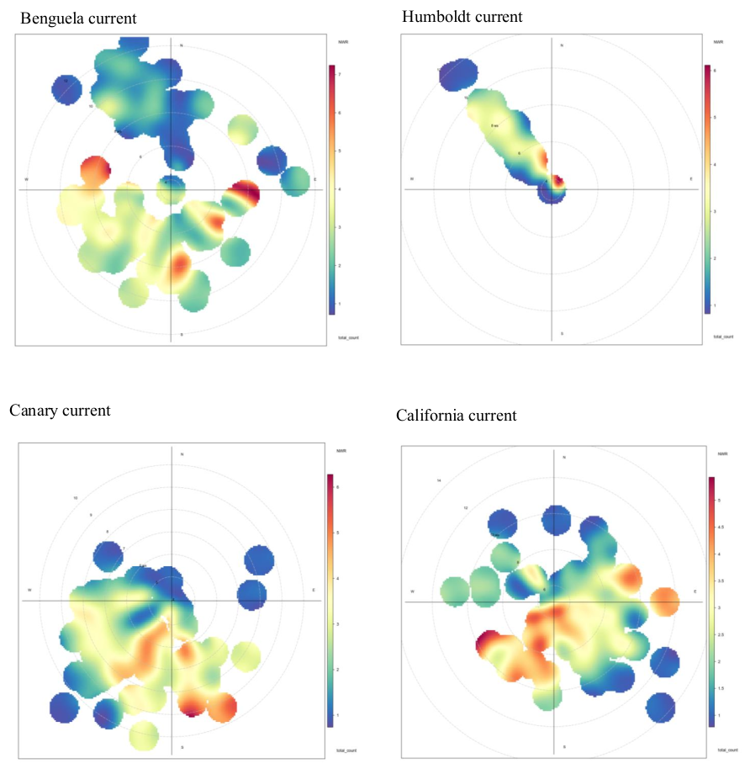

Fig.1. Bivariate polar plot of the total number of signals detected anually from 1982 – 2012. The colour scale shows the total number of signals detected and the radial scale shows the wind speed, which increases from the centreof the plot raidially out-wards.

Following the non-parametric wind regression approach with a kernel smoother, as demonstrated by Henry et al. (2009); it was found that upwelling signals in the Benguela current were predominantly abundant at wind speeds of 6-10 m.s-1(figure 1). Moreover it was found that the largest number of signals were associated with south-easterly and south-westerly winds, and occurred most frequently at wind speeds of approximately 8 m.s⁻¹. The frequency of upwelling signals derived from north-westerly winds were comparatively lower, with those signals only occurring at wind speeds exceeding 6 m.s⁻¹. Furthermore, at wind speeds in the range of 4 m.s-1, occurring in a north-easterly direction, the number of signals varied from 3 – 6 signals detected; whereas north-westerly winds, occurring at speeds of 6 – 10 m.s⁻¹ demonstrated 2-4 signals detected.
The Canary current presented the highest amount of signals detected in the south-easterly direction, with a total count of 3-6 signals. This fact was particularly evident when compared to the lower number of signals detected for winds of the north-easterly and north-westerly directions at speeds from 4-10 m.s⁻¹. However, for those south-westerly occurring winds, at speeds from 4-9 m.s⁻¹, the total number of signals detected ranged from 1-5.
The California current demonstrated the highest number of signals detected, occurring at a speeds of 4 m.s⁻¹ and extending to 10 m.s⁻¹,within this range, the number of signals detected varied from 3-5 signals. For those winds of a north-easterly and north-westerly direction, fewer signals were detected; conversely at a south westerly direction the number of signals increases, ranging between 3-5 signals at the wind speed range of 6-10 m.s⁻¹.

Table 2
The three most intense signals (mean intensity) detected per current from 1982 - 2012. The start date column gives the day on which the signal began and the duration column shows how many days the signal lasted for. The mean intensity represent the mean temperature anomaly during the signal with the cummulative intensity being the sum of the daily intensity anomalies over the duration of the signal.

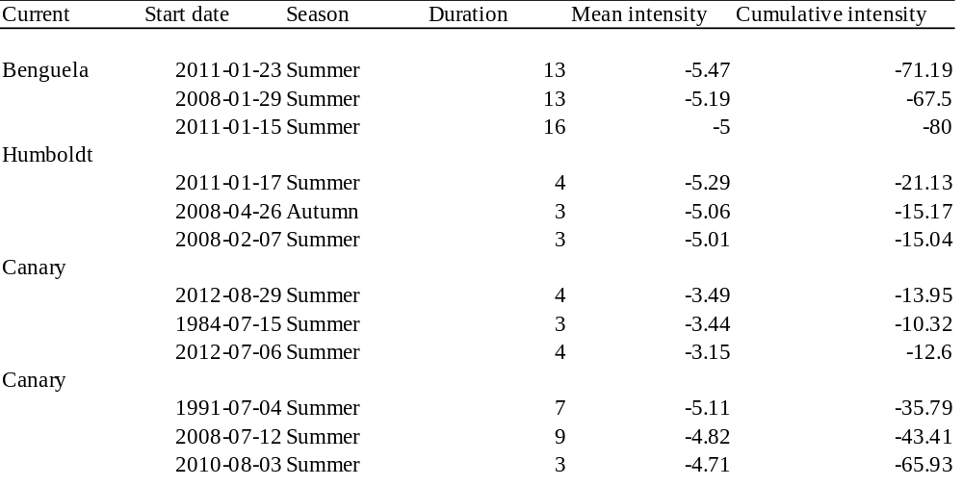

The three most intense signals (highest mean intensity) detected were all recorded in summer months for the Benguela current (Table 2). The duration of these events lasted between 13-16 days. The mean intensity of the three most intense signals in the Humboldt current were in the same range as the mean intensity in the Benguela current however, one of the events occurred in the autumn season, representing a mean intensity of -5.06, with the rest of the signals occuring during the summer season. The duration of the events detected also lasted for much fewer days compared to Benguela region (Table 2). The Canary current represents a lower mean intensity than that of the Benguela, Humboldt and California current. However, the most intense signals were detected in summer months for both the Canary current and Benguela current respectively.

In order to test for variation in metrics over a 30 year period, an ANOVA analyses was conducted; results of which indicated no significant difference in the number of signals detected within the Benguela current over the aforementioned period per year (F = 0.04, SS = 1.2, p = 0.83). Similarly, results obtained from analysis of the Humboldt current also showed no significant difference in the count per year (F = 0.40, SS = 10.90, p = 0.53). Analyses of the Canary and California currents however did reveal a significant difference in the number of signals per year; specifically, in the Canary current (F = 3.95, SS = 53.90, p < 0.05), and California current (F = 5.11, SS = 133.80, p <0.02). When observing if changes occurred in the intensity of events over a thirty year period; it is evident that the Benguela current did not show any significant difference in the intensity of events overtime (F =1.92, SS = 21329, p =0.17). Similarly, the Humboldt (F = 3.01, SS = 1002, p = 0.08, Canary (F = 0.27, SS = 732, p 0.60) and California (F = 1.02, SS = 574, p = 0.32) currents also showed no significant difference in the intensity of signals detected.

